Thursday, September 24th, at 7 pm, starting PNWAS Meetings on ZOOM

The Late-glacial Tanwax Flood and Debris Flow—An Ice-Age Flood from the Cascade Range into the Puget Lowland and Likely Source of Sediments for the Mima Mounds

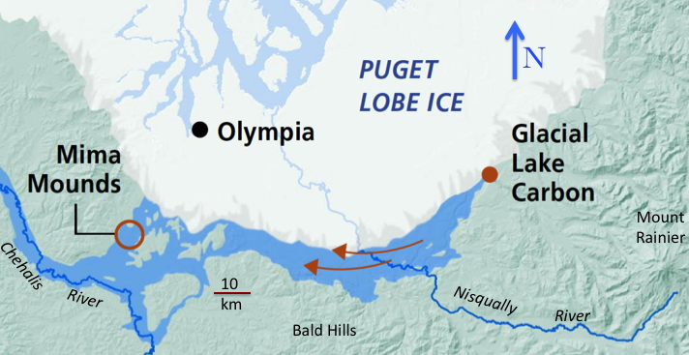

By Pat Pringle, Research Geologist,
Professor Emeritus of Earth Sciences, Centralia College

The Puget Lobe of the Vashon Glacier blocked the Carbon River at the time of the last glacial maximum about 17,000 years ago. A large lake filled the Carbon River and adjoining areas of the ice margin. Sometime later the lake level dropped by more than 50 meters as indicated by the levels of existing kame terraces, releasing a large flood of water that carved into sediments of the Puget Lowland creating and deepening the Tanwax, Ohop, and other valleys. The flood also triggered a number of landslides that transformed into debris flows whose equivalent deposits can be traced more than 100 km flow distance to the west. Equivalent deposits (rich in andesite) can be found in Rocky, Violet, Mima, and Ford Prairies, Tenino, and the Skookumchuck and Chehalis River valleys.

The flood merged with outwash from the Puget Lobe in the Black River Valley and continued downstream in the Chehalis River. Both the flood and discharge from the Puget Lobe into the Chehalis River modified the landscape of the southernmost Puget Lowland and Chehalis River. Although the floods of water would have posed a temporary obstacle to movement of people, the prairie landscapes left behind proved favorable for human use and travel.

[this is based on work Barry Goldstein of University of Puget Sound (UPS) and I have done over the past 20 years]

Patrick Pringle is Professor Emeritus of Earth Sciences at Centralia College. He previously was a research geologist at the Washington Geological Survey and at US Geological Survey Cascades Volcano Observatory. He studies volcanoes, earthquakes, landslides, and debris flows using radiocarbon and tree-ring analysis to establish the history of past geologic events. He is the author of books on the roadside geology of Mounts St. Helens and Rainier and has won several teaching awards.

